Huxley Cup Competition 2022
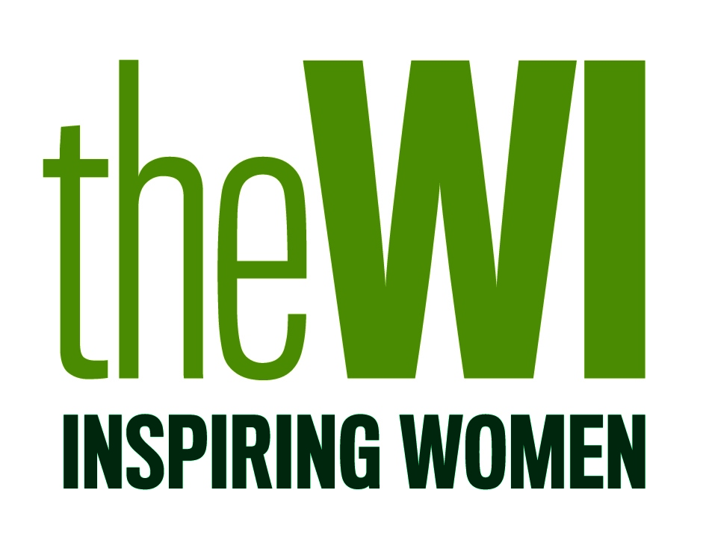

Fabulous Flying Friends - Inspiring women
across the country to create a greener and cleaner
place to live

This competition is open to all WI members; entries must be submitted on behalf of the WI and not as an individual. Members of the WI are encouraged to work together to compose a design which will then be submitted under the name of the WI, and not a specific individual. Only 1 entry per WI will be accepted.

WIs must submit their finished design directly to the NFWI for judging (not via federations as per previous competitions). Deadline for entries is FRIDAY 19 AUGUST 2022 (address to submit entries to be confirmed by end of July 2022). Each entry must be accompanied by a WI Entry Form.

Cost of entering is £10 (inc.VAT) per WI; please do not submit payment with your entry. An invoice will be sent to the WI from the NFWI Finance Department, after the closing date.

WI Entry Form

WI
Federation

Contact details for representative of the WI

(Ms/Mrs/Miss) SURNAME
FIRST NAME
ADDRESS
Post Code
Telephone
Email

The winning entry, runners up plus a selection of chosen entries will be retained by the NFWI for display purposes until December 2022. The NFWI reserves the right to use images of these entries on WI social media channels, My WI and in WI Life. Photographs will be acknowledged to the WI.

SIGNED: .............................................................. DATE: ......................................................

