Chelsea College of Arts and the Women’s Institute
Application of Interest

Chelsea College of Arts, in partnership with the NFWI, are looking for skilled and forward-thinking craftswomen of the WI to take part in a project with BA Textile Design students from the Chelsea College of Arts that will encourage skill-sharing, communication and creativity.

If you are interested in taking part in this exciting new project, please complete and return this form to h.neal@nfwi-unit.org.uk

Full name:
Address:
Telephone:
Mobile:
Email:
WI:
Federation:

Do you have any craft skills or experience? If so, please provide further details:

Supporting Statement

Please briefly tell us why you would like to take part in the project:
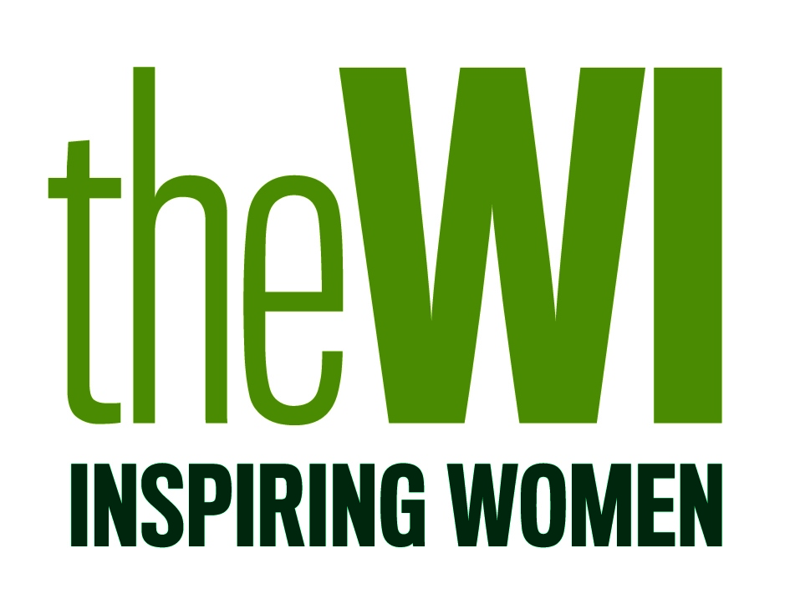
Please note: information given on this form will remain confidential, kept securely and used for admin purposes only. This information will not be shared with any other parties outside of the project and will be destroyed at the end of the activity.

