INSPIRING WOMEN…
saying ‘thank you’ through music

Let’s start with a quick reminder…
This is your opportunity to thank those who aren’t thanked enough, the country’s unsung heroes. So many people change their lives to care for others and give tireless friendship and dedication to loved ones with dementia so they can stay in their own homes and live their best lives possible. Music is perfect for creating those moments of connection and to say Thank You.

Across the country, we are calling out to all WIs to start practising and get ready to sing on 2 July by organising flash mobs in your local area; in the aisles of your local supermarket, local care homes, town centres, anywhere where you can pass on the message and brighten someone’s day.

Full pack of resources include backing track, sheet music (individual, piano and choir), advertisement etc can all be found at https://mywi.thewi.org.uk/interests/celebrate-thank-you-day-2023 or https://thankyouday.org.uk/

Song Release Date: June 27th
You will have recently seen that #ThankYouDay are re-recording 'Thank You for Being a Friend' with Tony Christie and our very own WI supporter, Katie, was invited to be on the track.

Katie joined as a WI Supporter on her 18th birthday in May 2023, and is a strong believer in giving all girls and women the confidence to have a voice on current and relevant issues that affect today's generation. She says, 'taking part in this song was a once-in-a-life time experience and I was so nervous, but I was proud to have been chosen to represent the WI and stand to thank all WI members, particularly those who are carers or have been affected by dementia.'

"Thank You for Being a Friend," will premiere on BBC Breakfast on 27 June - make sure to tune in to see Katie and the talented VIPs involved in this amazing song.

FLASH MOB! Sing with Tony Christie at St Pancras Station, London
On Sunday 2 July, at 2pm, 2.30pm and 3pm Tony Christie will be performing live 'Thank you for being a friend' in St Pancras Station and we have been asked if we could provide a 'WI flash mob' to sing along with Tony. Although we already have enlisted some fabulous members to join us on the day, we are still looking for more members who are available on the 2 July 2023 and willing to take part. Don't worry, there won't be choreographing a dance routine to go alongside the singing, we just want members dispersed amongst the crowd and spontaneously break into song with Tony Christie. All you'll need to do is learn the song - for ease, I've attached all the resources which you'll need (previously shared with federations and available to download from My WI).

If you are local to London, willing to travel or planning to visit on the 2 July and fancy joining a sing-along with Tony at St Pancras, please do let us know asap h.neal@nfwi.org.uk (please note, we are unable to offer any financial reimbursement for this, but we can promise you a great afternoon).

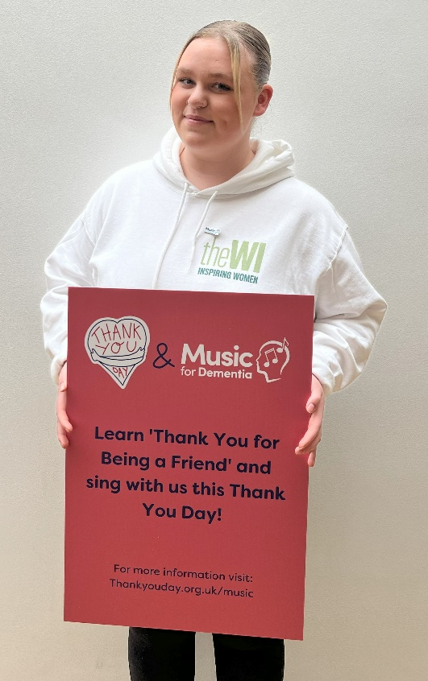
Practice your vocals!
Join Clare Dove from Choral Hub on Wednesday 21 June at 7.30pm to get your voice in shape ready to sing 'Thank you for being a friend' as part of the Thank You Day celebrations on the 2 July. This session is free to attend and will teach members how to warm up their voices and get the most out of the song, simply click on the link below to sign up.

www.denman.org.uk/at-home/courses/TYDSingingRehearsal

Working with Asda and Dementia Carers Count
Asda Community Champions are welcoming WIs to use their stores to host their flash mobs – and may even rope in a few employees to take part! Please contact your local Community Champion to find out more (participating stores and list of Champions available to view in resources ack of by emailing: community@storename@asda.co.uk
(example: community@slough@asda.co.uk)

Dementia Carers Count (DCC) is a national charity which supports people looking after someone with dementia. Community Manager, Yael Shotts would be delighted to come and speak to WIs about the support DCC offers. You can email her (yael.shotts@dementiacarers.org.uk) to arrange this. This may be of direct help for members, or it may enable members to encourage people they know, who are caring for someone with dementia, to approach DCC for support.

Media Opportunities
As we lead up to the big day, we are expecting media requests for filming locations and interviews with participants - there may also be VIPs in need of venues! To help us manage these types of requests, it would be great to have an idea of what WIs around the country as planning; we just need to know your WI and federation, date of event/activity, location and the name and email for a key contact. Please email h.neal@nfwi.org.uk

This type of information is also really helpful for when we evaluate our work, so even if you don’t want to be involved in any media, we’d still love to hear from you.

