Holiday in Gloucestershire hosted by the Gloucestershire Federation
We invite you to join us for an opportunity
to enjoy a tour of Gloucestershire
from Monday 16th September to Friday 20th September 2024

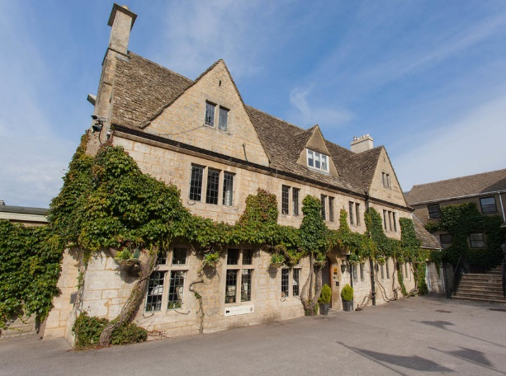
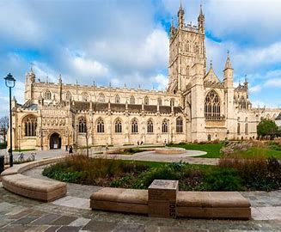
You will be staying at a country house hotel, Hatton Court, Upton St Leonards, GL4 8DE for 4 nights half board, with full English breakfast and a three-course dinner taken in a private dining room. The hotel, situated on the edge of the Cotswolds, has ample parking, gardens and terrace with views across the Severn Valley to the Forest of Dean and Wales. All rooms are ensuite and situated on the first floor. Please note you will need to negotiate stairs, some of which are external as there is no lift, help will be given with luggage.
All transport to the tour venues will be by coach. The first day will be spent in Gloucester for a tour of the Cathedral followed by free time to explore the city and its docks. There are plenty of cafes for lunch after which we meet up to go on to Nature in Art a well-established museum and Art Gallery on the outskirts of Gloucester.
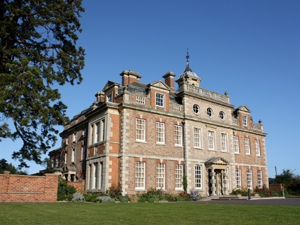
On day two we plan a visit to Beckford Silk where you will be given a tour showing the process of making exclusive scarves. We will then depart to travel to Adam Henson’s Cotswold Farm Park of Countryfile fame. There will be a short introductory talk and an opportunity to have lunch and spend the afternoon looking around the park, seeing the rare breeds.

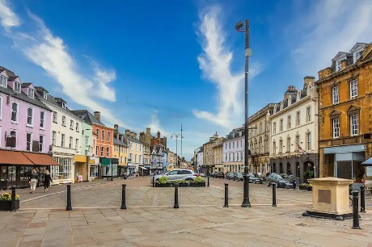
On the final day we will take you to Cirencester for a chance to explore this delightful and historic Cotswold town. After lunch at a venue of your choice, we move to Highgrove House for an exclusive tour of His Majesty’s gardens. (This is dependent on the King’s diary and cannot be confirmed until the New Year, we will let you know as soon as we can but will arrange a different itinerary for this day if necessary.)
The cost for the holiday is £493 per person sharing a room,
husbands, partners, friends are welcome. Price for single accommodation on request.

Application Forms are available from our office Tel: 01452 523966 or email admin@gfwi.org.uk.
Further information is available from the organisers
Janice Cole janicatellinis@aol.com & Liz Goldie liz.goldie27@gmail.com

A non-returnable deposit of £50 is required to secure a place.
We strongly advise taking out holiday insurance, this is not provided by GFWI.
We look forward to welcoming you to our special county.

